

REPORT ON
CD Mini Project Carried out on

DESIGNING A COMPILER FOR A HYPOTHETICAL
LANGUAGE
Submitted to

NMAM INSTITUTE OF TECHNOLOGY, NITTE
(Deemed to be University)

In partial fulfilment of the requirements for the award of the

Degree of Bachelor of Technology in Computer Science and Engineering

By

SHALDON BARNES NNM23CS172
RONAK SHETTY NNM23CS157
JILAGAM SATYA SRI PRASAD NNM24CS507

Submitted to,

Dr. Raju K

Professor
Department Of Computer Science and Engineering



CERTIFICATE

This is to certify that Shaldon Barnes NNM23CS172, Ronak Shetty NNM23CS157 and Jilagam Satya Sri Prasad NNM24CS507 of 6th semester B.Tech, a bonafide student of NMAM Institute of Technology, Nitte, has completed CD mini project on “Designing a Compiler for a Hypothetical Language” during March 2025 -April 2025 fulfilling the partial requirements for the award of degree of Bachelor of Technology in Computer Science & Engineering at NMAM Institute of Technology, Nitte

_________________________ _______________
Name and Signature of Mentor Signature of HOD

ACKNOWLEDGEMENT

The satisfaction and euphoria that accompany the successful completion of any task would be incomplete without the mention of people who made it possible because “Success is the abstract of hard work and perseverance, but steadfast of all is encouraging guidance.” So I acknowledge all those whose guidance and encouragement served as a beacon light and crowned my efforts with success.

I would like to thank our principal Prof. Niranjan N. Chiplunkar firstly, for providing us with this unique opportunity to do the Mini Project in the 6th semester of Computer Science and engineering.

I would like to thank my college administration for providing a conductive environment and also suitable facilities for this mini project. I would like to thank our Hod Dr. Jyothi Shetty for showing me the path and providing the inspiration required for taking the project to its completion.

It is my great pleasure to thank my mentor Dr. Raju K for his/her continuous encouragement, guidance, and support throughout this project.

Finally, thanks to staff members of the department of CSE, my parents and friends for their honest opinions and suggestions throughout the course of our mini project.

Shaldon Barnes (NNM23CS172) Ronak Shetty (NNM23CS157)
Jilagam Satya Sri Prasad (NNM24CS507)

TABLE OF CONTENTS

Title | Page No.
Cover Title | 1
Institute Certificate | 2
Acknowledgement | 3
Table of Contents | 4
Abstract | 5
Introduction | 6 - 7
Design | 8
Problem Statement and explanation | 9 - 11
Implementation Details | 12-18
Result | 19-23
Conclusion | 24
References | 25

ABSTRACT

This project focuses on designing a Lexical Analyzer and Syntax Analyzer for a given Context-Free Grammar (CFG). These two stages are essential components of the analysis phase in the compilation process, where the source code is first broken into meaningful tokens and then checked for syntactic correctness based on grammar rules.
The system takes two main inputs: a hypothetical source program and the corresponding grammar rules. The Lexical Analyzer processes the source code to identify tokens, while the Syntax Analyzer validates the token sequence using LL(1) parsing, a top-down parsing technique that relies on a single look ahead symbol.
A parse table is generated from the grammar, containing entries for terminals and non-terminals, guiding the parser through the parsing process. The final result is a parsed sequence that can be used in subsequent phases of compilation like semantic analysis or intermediate code generation.
This project showcases the core principles of compiler construction and demonstrates the practical application of LL(1) parsing in building a simplified yet functional compiler front-end.

INTRODUCTION
COMPILER:
A compiler is a software that takes a program written in a high-level language and translates it into an equivalent program in a target language. Most specifically a compiler takes a computer program and translates it into an object program. Some other tools associated with the compiler are responsible for making an object program into executable form.

Source program – It is normally written in a high-level programming language.
It contains a set of rules, symbols and special words used to construct a computer program. Target program – It is normally the equivalent program in machine code. It contains the binary representation of the instructions that the hardware of the computer can perform.

Error Message – A message issued by the compiler due to detection of syntax errors in the source program. Compilation is a large process. It is often broken into stages. Many phases of the compiler try to optimize by translating one form into a better (more efficient) form. Most of compiling is about “pattern matching” languages and tools that support pattern matching, are very useful.
An efficient compiler must preserve semantics of the source program and it should create an efficient version of the target language.
PHASES OF COMPILER:The process of compilation is divided into several phases, each of which transforms the source program from one representation to another as shown in Fig 1.
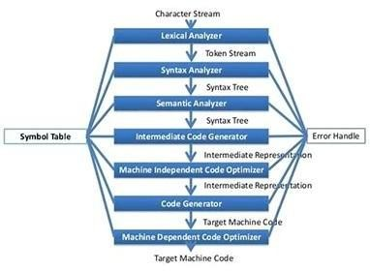

Fig 1 : Phases of Compiler

- Lexical Analysis: This is the first phase of a compiler, also known as scanning. The lexical analyzer reads the stream of characters that make up the source program and groups them into meaningful sequences calledlexemes. For each lexeme, the lexical analyzer produces a token in the form of (token-name, attribute-value).

- Syntax Analysis: This is the second phase of the compiler, also known as parsing. The parser uses the first components of the tokens produced by the lexical analyzer to create A tree-like intermediate representation that depicts the grammatical structure of the token stream.

- Semantic Analysis: The semantic analyzer uses the syntax tree and the information in the symbol table to check the source program for semantic consistency with the language.
- definition. It also gathers type information and saves it in either the syntax tree or the symbol table for subsequent use during intermediate-code generation.

- Intermediate Code Generation: During the translation of a source program into target code, a compiler may construct one or more intermediate representations. Syntax trees are a form of intermediate representation commonly used during syntax and semantic analysis.

- Code Optimization: The machine-independent code-optimization phase attempts to improve the intermediate code so that better target code will result. Usually, “better” means faster, but other objectives may be desired, such as shorter code or target code that consumes less power.

- Code Generation: The code generator takes the intermediate representation of the source program as input and maps it into the target language. If the target language is machine code, registers or memory locations are selected for each of the variables used by the program. Then, the intermediate instructions are translated into sequences of machine instructions that perform the same task.

Each phase of the compiler plays a crucial role in transforming the high-level source code into low-level machine code. The phases are designed to sequentially analyze, transform, and optimize the code to ensure efficient execution.

DESIGN
Lexical Analyzer:

Lexical analysis is the process of converting a sequence of characters from a source program which is taken as input to a sequence of tokens.
A lexical analyzer/lexer/scanner is a program which performs lexical analysis as shown in Fig 2.

The roles of lexical analyzer are:

- Reading of input characters from the source program.
- Correlation of error messages with the source program.
- Striping white spaces and comments from the source program
- Expansion macros if found in the source program.
- Entering identified tokens to symbol table.

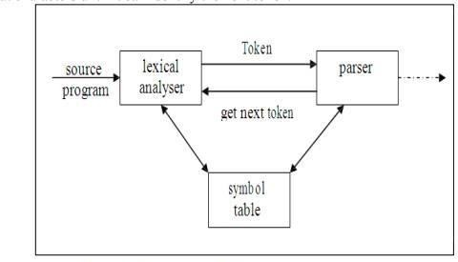
Fig2 : Lexical Analyzer with parser

Problem Statement:
Design compiler for the following hypothetical languages:

BEGIN
PRINT “HELLO” INTEGER A, B, C REAL D, E STRING X, Y
A := 2
B := 4
C := 6
D := -3.65E-8
E := 4.567
X := “text1”
Y := “hello there” FOR I:=1 TO 5
PRINT “Strings are [X] and [Y]” END

Lexical Analysis:
The initial phase of the compiler, lexical analysis, is responsible for scanning the raw source code and transforming it into a sequence of tokens. These tokens represent the smallest meaningful units in a programming language, such as identifiers, keywords, operators, and delimiters. This stage eliminates unnecessary elements like whitespace and comments, thus simplifying the input for the next phase - syntax analysis.
In the implemented compiler, the lexical analyzer reads the source code character by character, validates each segment against defined token patterns, and outputs a token stream. If an unrecognized character sequence is encountered, the analyzer promptly flags a lexical error. By providing clean and accurate token sequences to the parser, this stage significantly enhances the efficiency and reliability of the compilation process.
Token:
A token is a logical unit of the source code identified during lexical analysis. Common tokens include keywords (if, while, int), identifiers (x, counter), operators (+, -, =), literals (123, 'a'), and punctuation symbols ((, ), ;). Each token corresponds to a specific type and plays a key role in defining the syntax of the program.

Pattern:
Patterns are predefined rules or regular expressions that specify how to recognize valid tokens. For instance, a pattern for an identifier might require the first character to be a letter followed by any number of letters or digits. These patterns guide the lexical analyzer in distinguishing between valid and invalid sequences of characters.

Lexeme:
A lexeme is the actual string of characters in the source code that matches a specific token pattern. For example, in the token identifier(x), the lexeme is x. Lexemes are the concrete substrings that are matched against token definitions during lexical analysis.
Syntax Analysis:
Following lexical analysis, syntax analysis (or parsing) receives the stream of tokens and checks whether they form a syntactically correct program based on a given grammar. This phase constructs a parse tree that represents the syntactic structure of the input program. In the presence of syntax errors, the parser provides informative error messages and, where possible, performs error recovery to proceed with further analysis.
The grammar used in this project is a Context-Free Grammar (CFG). The parser uses an LL(1) parsing technique, which is a top-down, predictive parsing approach. It reads the input from Left to right, constructs a Leftmost derivation, and uses 1-token lookahead to make parsing decisions. This method offers a simple and efficient way to parse input for grammars that are unambiguous and suitable for LL(1) construction.

Parser:
The parser in this project implements the LL(1) parsing strategy. It uses a parsing table
constructed based on the FIRST and FOLLOW sets of the grammar. With the help of a stack and a lookup table, the parser decides how to expand non-terminals based on the current input token and the symbol on top of the stack.
- If the stack top is a terminal and matches the current input token, the token is consumed.
- If the stack top is a non-terminal, the parser consults the parsing table to determine the appropriate production rule.
- If the table provides no rule or there is a mismatch, a syntax error is reported.
The parsing process continues until the input tokens are fully matched and the stack is emptied, indicating successful parsing.
This technique is straightforward to implement and ideal for grammars designed to be LL(1)-compatible. Unlike bottom-up parsers such as LR or SLR, the LL(1) parser does not require complex state transitions or reductions, making it both intuitive and educationally beneficial for understanding compiler fundamentals.

IMPLEMENTATION DETAILS

The parser in this project implements the LL(1) parsing strategy. It uses a parsing table constructed automatically using the FIRST and FOLLOW sets generated from the given grammar. With the help of a stack and a lookup table, the parser decides how to expand non-terminals based on the current input token and the symbol on top of the stack.
The source program is entered dynamically by the user, and the lexical analyzer first converts it into a stream of valid tokens. These tokens are then passed to the parser for syntax validation.
● If the stack top is a terminal and matches the current input token, the token is consumed.
● If the stack top is a non-terminal, the parser consults the parsing table to determine the correct production rule.
● If the table provides no rule or a mismatch occurs, a syntax error is reported.
● Each parsing step is displayed clearly, showing the stack contents, current input symbol, and parser action.
The parsing process continues until all input tokens are matched and the stack becomes empty, indicating successful parsing.
This technique is simple, efficient, and suitable for grammars designed to be LL(1)-compatible. Unlike bottom-up parsers such as LR or SLR, the LL(1) parser does not require complex states or reductions, making it easier to implement and understand. It is highly useful for learning the basic concepts of syntax analysis and compiler design.
Source Code:

import re
from tabulate import tabulate
from collections import defaultdict

# =========================
# LEXER
# =========================

keywords = {'BEGIN', 'PRINT', 'INTEGER', 'REAL', 'STRING', 'FOR', 'TO', 'END'}

token_specification = [
('KEYWORD', r'\b(?:BEGIN|PRINT|INTEGER|REAL|STRING|FOR|TO|END)\b'),
('NUMBER', r'-?\d+\.?\d*(?:[Ee][+-]?\d+)?'),
('STRING', r'"[^"]*"'),
('IDENTIFIER', r'\b[a-zA-Z_]\w*\b'),
('OPERATOR', r':=|;|,'),
('NEWLINE', r'\n'),
('SKIP', r'[ \t]+'),
('MISMATCH', r'.'),
]

tok_regex = '|'.join(f'(?P<{name}>{pattern})' for name, pattern in token_specification)

# =========================
# FIXED INPUT
# =========================

source_code = """
BEGIN
PRINT "HELLO" ;
INTEGER A, B, C ;
REAL D, E ;
STRING X, Y ;
A := 2 ;
B := 4 ;
C := 6 ;
D := -3.56E-8 ;
E := 4.567 ;
X := "text1" ;
Y := "hello there" ;
FOR I := 1 TO 5
PRINT "Strings are [X] and [Y]" ;
END
END
"""

# =========================
# TOKENIZATION
# =========================

tokens = []
token_stream = []
token_values = {}
token_id = 1

kw_set, id_set, lit_set = set(), set(), set()

for mo in re.finditer(tok_regex, source_code):
kind = mo.lastgroup
value = mo.group()

if kind in ['SKIP', 'NEWLINE']:
continue

if kind == 'MISMATCH':
raise RuntimeError(f"Unexpected token: {value}")

if kind == 'IDENTIFIER' and value in keywords:
kind = 'KEYWORD'

if value not in token_values:
token_values[value] = token_id
token_id += 1

tokens.append((kind, value, token_values[value]))

if kind == 'IDENTIFIER':
token_stream.append('IDENTIFIER')
id_set.add(value)

elif kind == 'NUMBER':
token_stream.append('NUMBER')
lit_set.add(value)

elif kind == 'STRING':
token_stream.append('STRING')
lit_set.add(value)

else:
token_stream.append(value)
if kind == 'KEYWORD':
kw_set.add(value)

token_stream.append('$')

# =========================
# GRAMMAR
# =========================

grammar = {
"program": [["BEGIN", "stmt_list", "END"]],
"stmt_list": [["stmt", "stmt_list"], ["ε"]],
"stmt": [["PRINT", "expr", ";"],
["declaration"],
["assignment"],
["for_loop"]],
"declaration": [["type", "var_list", ";"]],
"type": [["INTEGER"], ["REAL"], ["STRING"]],
"var_list": [["IDENTIFIER", "var_list_tail"]],
"var_list_tail": [[",", "IDENTIFIER", "var_list_tail"], ["ε"]],
"assignment": [["IDENTIFIER", ":=", "expr", ";"]],
"for_loop": [["FOR", "IDENTIFIER", ":=", "expr", "TO", "expr", "stmt_list", "END"]],
"expr": [["IDENTIFIER"], ["NUMBER"], ["STRING"]]
}

non_terminals = list(grammar.keys())
terminals = set()

for head, prods in grammar.items():
for prod in prods:
for sym in prod:
if sym not in grammar and sym != "ε":
terminals.add(sym)

terminals.add('$')

# =========================
# FIRST SET
# =========================

FIRST = defaultdict(set)

def first(symbol):
if symbol in terminals:
return {symbol}

result = set()

for prod in grammar[symbol]:
if prod[0] == "ε":
result.add("ε")
else:
for sym in prod:
f = first(sym)
result |= (f - {"ε"})
if "ε" not in f:
break
else:
result.add("ε")

return result

for nt in non_terminals:
FIRST[nt] = first(nt)

# =========================
# FOLLOW SET
# =========================

FOLLOW = defaultdict(set)
FOLLOW["program"].add('$')

changed = True

while changed:
changed = False

for head, prods in grammar.items():
for prod in prods:
for i, B in enumerate(prod):

if B in non_terminals:
beta = prod[i+1:]

if beta:
first_beta = set()

for sym in beta:
first_beta |= (first(sym) - {"ε"})
if "ε" not in first(sym):
break
else:
first_beta.add("ε")

before = len(FOLLOW[B])
FOLLOW[B] |= (first_beta - {"ε"})

if "ε" in first_beta:
FOLLOW[B] |= FOLLOW[head]

if len(FOLLOW[B]) > before:
changed = True

else:
before = len(FOLLOW[B])
FOLLOW[B] |= FOLLOW[head]

if len(FOLLOW[B]) > before:
changed = True

# =========================
# PARSING TABLE
# =========================

parsing_table = defaultdict(dict)

for head, prods in grammar.items():
for prod in prods:

first_set = set()

if prod[0] == "ε":
first_set.add("ε")
else:
for sym in prod:
first_set |= (first(sym) - {"ε"})
if "ε" not in first(sym):
break
else:
first_set.add("ε")

for t in first_set - {"ε"}:
parsing_table[head][t] = prod

if "ε" in first_set:
for t in FOLLOW[head]:
parsing_table[head][t] = prod

# =========================
# LL(1) PARSER
# =========================

stack = ["$", "program"]
input_ptr = 0
actions = []
step = 1

while stack:

top = stack[-1]
current = token_stream[input_ptr]

actions.append([step, " ".join(stack), current, ""])

if top == current == "$":
actions[-1][3] = "Accept"
break

elif top == current:
stack.pop()
input_ptr += 1
actions[-1][3] = f"Match {current}"

elif top in terminals:
actions[-1][3] = "ERROR"
break

else:
if current in parsing_table[top]:
prod = parsing_table[top][current]
stack.pop()

if prod != ["ε"]:
stack.extend(reversed(prod))

actions[-1][3] = f"{top} -> {' '.join(prod)}"

else:
actions[-1][3] = "ERROR"
break

step += 1

# =========================
# OUTPUT
# =========================

print("\nTOKEN TABLE")
print(tabulate(tokens, headers=["Type", "Lexeme", "ID"], tablefmt="fancy_grid"))

print("\nSYMBOL TABLES")

print("\nKeywords")
print(tabulate([[k] for k in sorted(kw_set)],
headers=["Keyword"], tablefmt="fancy_grid"))

print("\nIdentifiers")
print(tabulate([[i] for i in sorted(id_set)],
headers=["Identifier"], tablefmt="fancy_grid"))

print("\nLiterals")
print(tabulate([[l] for l in sorted(lit_set)],
headers=["Literal"], tablefmt="fancy_grid"))

print("\nGRAMMAR")
for k, v in grammar.items():
for prod in v:
print(f"{k} -> {' '.join(prod)}")

print("\nFIRST SETS")
print(tabulate([[k, ", ".join(FIRST[k])] for k in FIRST],
headers=["Non-Terminal", "FIRST"], tablefmt="grid"))

print("\nFOLLOW SETS")
print(tabulate([[k, ", ".join(FOLLOW[k])] for k in FOLLOW],
headers=["Non-Terminal", "FOLLOW"], tablefmt="grid"))

print("\nPARSING ACTIONS")
print(tabulate(actions,
headers=["Step", "Stack", "Input", "Action"],
tablefmt="grid"))

if actions[-1][3] == "Accept":
print("\nParsing completed successfully!")
else:
print("\nParsing failed!")

Results:
Token Table:
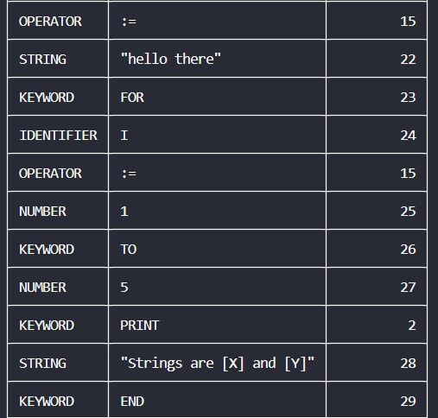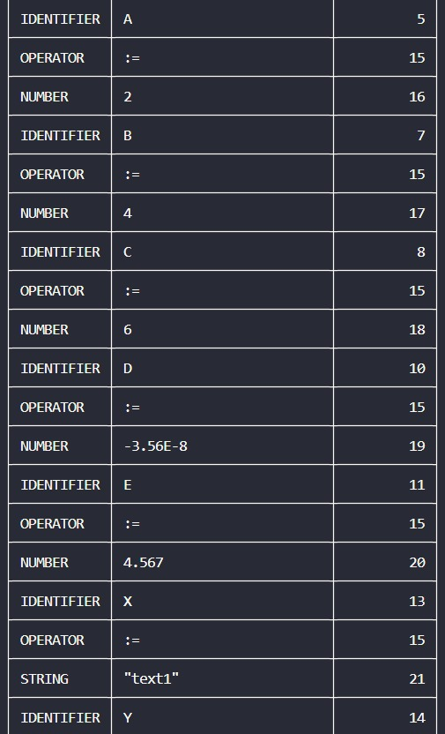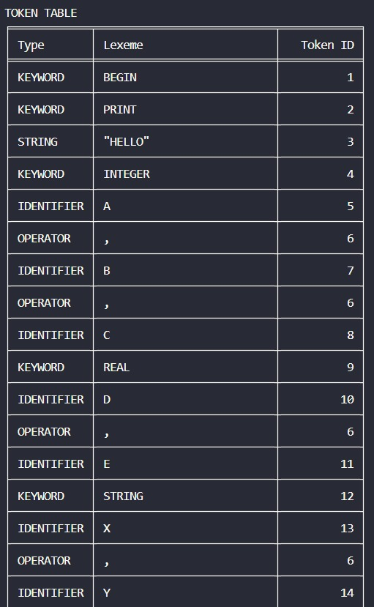

Symbol Tables:
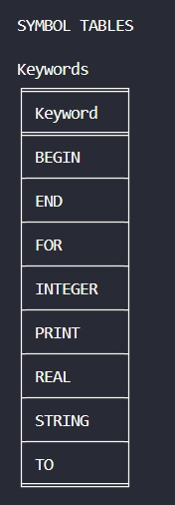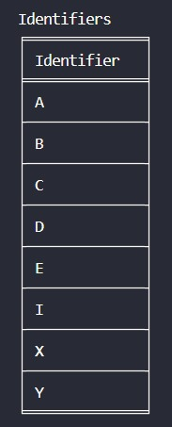
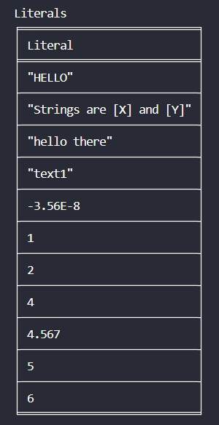
Grammar:
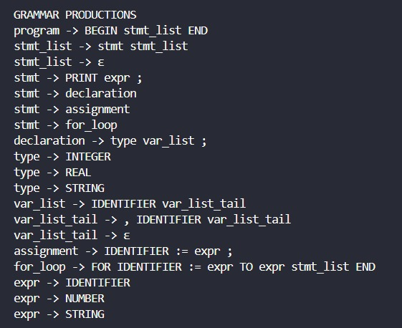

First and Follow set:

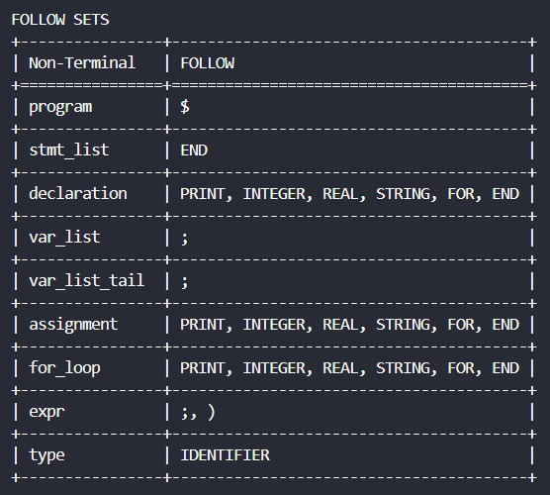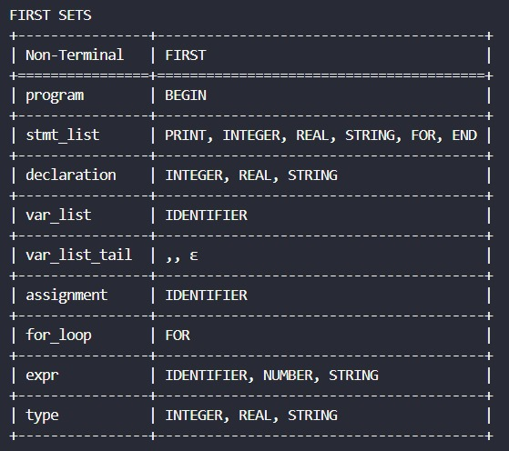

Parsing Table:

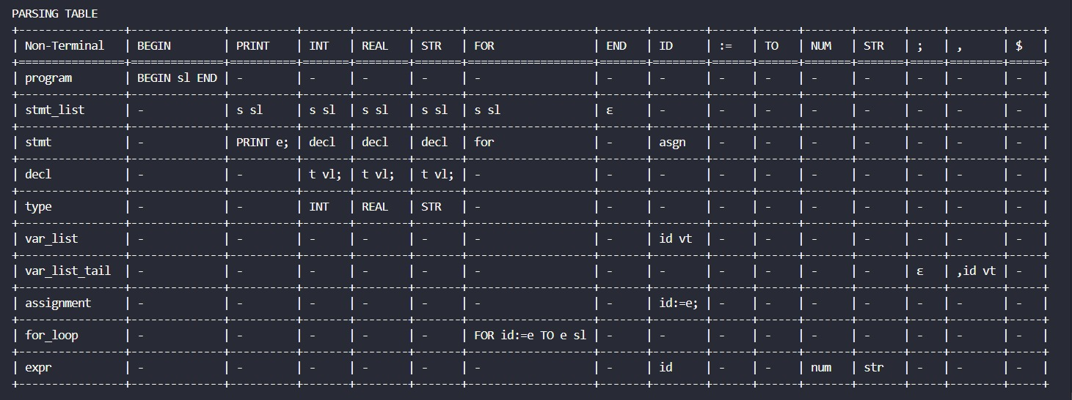
Parsing Action:

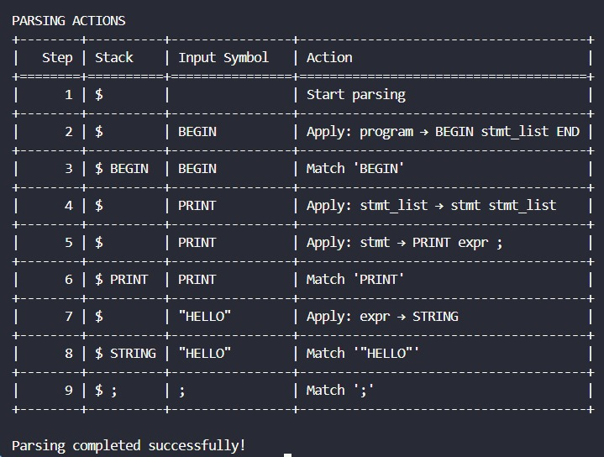

CONCLUSION

In this project, we gained a practical understanding of how a compiler processes a program by dividing the task into multiple well-defined phases, mainly lexical analysis and syntax analysis. The lexical analyzer played a crucial role in scanning the input source code and breaking it down into meaningful units called tokens. These tokens included keywords, identifiers (variables), numeric literals, string literals, operators, and delimiters. Each token was categorized and stored efficiently, and separate symbol tables were maintained for keywords, identifiers, and literals. This step helped us understand how raw source code is structured and interpreted by a compiler at a lower level.
Following lexical analysis, we focused on syntax analysis using a context-free grammar. The grammar rules defined the structure of valid statements in the language. Based on these rules, we computed the FIRST and FOLLOW sets, which are essential components in constructing an LL(1) parsing table. These sets helped determine how the parser makes decisions using a single lookahead token without backtracking.
Using the generated FIRST and FOLLOW sets, we constructed the LL(1) parsing table. This table served as the core of the predictive parser, allowing it to decide which production rule to apply at each step. The parsing process was then simulated step-by-step using a stack-based approach. At each stage, the parser compared the top of the stack with the current input token and performed actions such as matching terminals or expanding non-terminals based on the parsing table. This clearly demonstrated how a top-down parser validates the syntax of a program.
Through this implementation, we also understood important concepts such as leftmost derivation, predictive parsing, and the importance of eliminating ambiguity and left recursion from grammars to make them suitable for LL(1) parsing. The step-by-step parsing trace provided valuable insight into how the parser processes tokens and ensures that the input program follows the defined grammatical rules.
Overall, this project provided a comprehensive understanding of the fundamental phases of a compiler. It helped bridge the gap between theoretical concepts and practical implementation, giving us hands-on experience in designing a lexical analyzer and an LL(1) parser. This experience strengthened our understanding of compiler design principles and improved our ability to analyze and process programming languages systematically.

REFERENCES

- https://www.javatpoint.com/compiler-tutorial
- https://www.tutorialspoint.com/compiler_design/index.htm
- https://www.geeksforgeeks.org/compiler-design-tutorials/
- https://docs.python.org/3/library/re.html
- https://pypi.org/project/tabulate/

